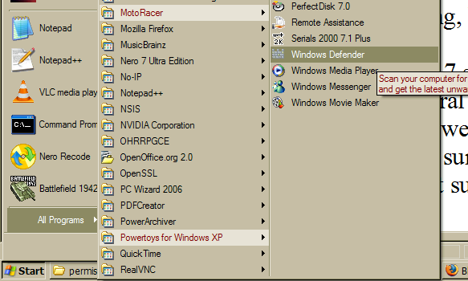 Windows Defender is already installed.

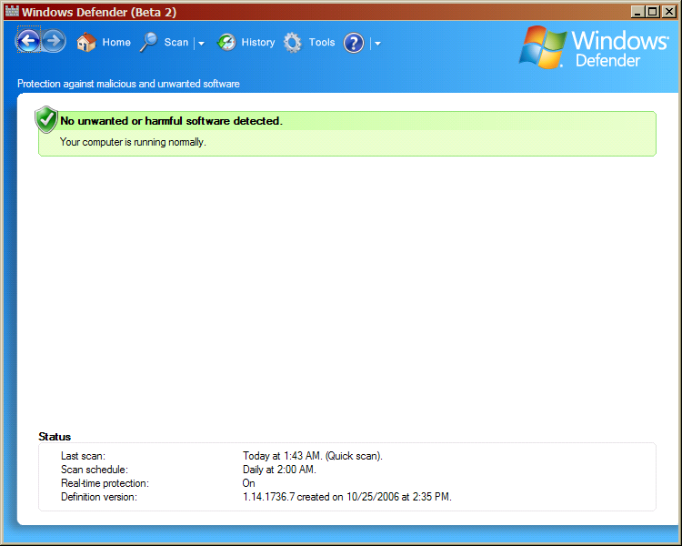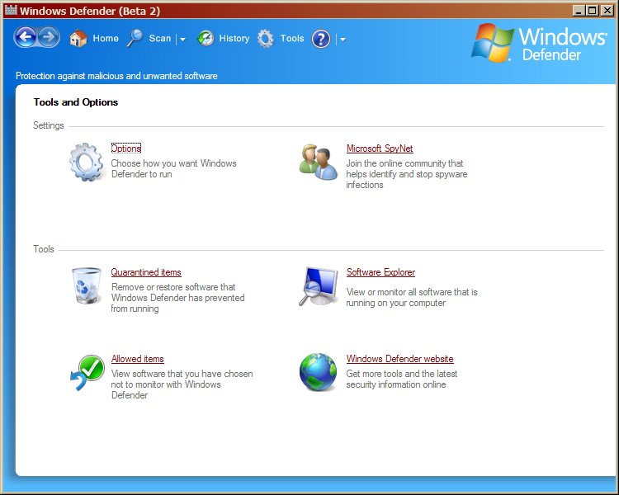

Summary
Windows Defender (formerly Microsoft AntiSpyware) is a very useful program. It might not be the best at fighting spyware (Ad-Aware and Spybot Search & Destroy are better), but it’s good enough for any user to want to install it. Personally, when I have spyware problems on other people’s machines, I install Spybot S&D and Windows Defender, so they know about issues when they occur, as well as being able to do better (more paranoid) searches. This lab helped me remember that I needed to turn off an annoying feature (it only shows the Defender icon when there’s a problem by default), but other than that, this is really standard procedure for me.

